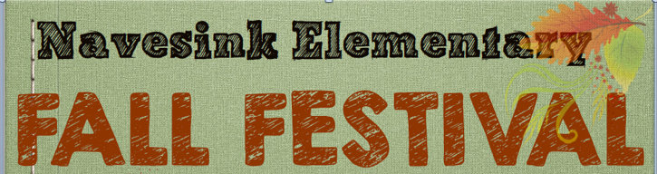

Pre-Order Fall Sale
Our Fall Festival on September 29th is the perfect kickoff to fall, and a great time to get your fall mums, hay and pumpkins. We also have Dearborn Market pies and donuts available for pre-order. All items ordered will be available for pickup at the Fall Festival. Please fill out the order form below and return with cash or a check made payable to Navesink PTA by Wednesday, 9/19 Attn: Fall Fest Pre-Order. To order online go to https://navesink.memberhub.store (memberhub.com adds a small processing fee)
All orders must be picked up at the Fall Festival by 4pm. Sales are Final, no refunds will be given if orders are not picked up.
Name:
Email:
Phone Number:
Items Available for Pre-Order | Price | Quantity | Total Price
Large Mums(colors will be assorted) | $8 each
Large Hay Bale | $10 each
Small Hay Bale | $7 each
Large Pumpkins | $8 each
Apple Pie | $12
Pumpkin Pie | $12
Apple Crumb Pie | $12
Apple Cider Donuts(Powdered) | $5
Apple Cider Donuts(Cinnamon Sugar) | $5
Apple Cider Donuts(Mixed) | $5
 |  | Total $
Pay by check, cash or go to https://navesink.memberhub.store

